What is it & who is it for?
The Zones are designed to help both children and adults identify emotions and tools to be able to regulate those emotions. Emotions can be confusing and overwhelming, and the Zones help us to learn to understand the connection between our sensory systems and our emotions, and how that relates to the world around us. It is about developing a social awareness.​
​
There are no 'bad' zones. We all experience being in these zones, but the intention is to teach people how to behave when they are in different zones.

This course has been designed for both children and adults. It is aimed towards those that struggle to regulate their emotions by displaying unexpected social behaviours when they are feeling strong feelings, for example angry outbursts. It is especially beneficial for neurodiverse children (ASD, ADHD) or children who have had traumatic experiences that don’t have the skills to regulate their emotions in a socially adaptive context.

When does it start?
The sessions can be started at any time during the term. One-on-one and group sessions are available. The same day/ time will be used throughout the 10-week program.

What’s included:
- 10 x one-hour sessions (approx.)
- Children will learn to identify their emotions and the behaviours they produce when they feel certain emotions
- They will learn which behaviours are expected and which are unexpected
- Children will try a variety of tools to find ones that suit them to help regulate their emotions and behaviours depending on which ‘Zone’ they are in
- Therapy Assistant will provide open email communication with guardians, and copies of the work that are completed on the day will be emailed
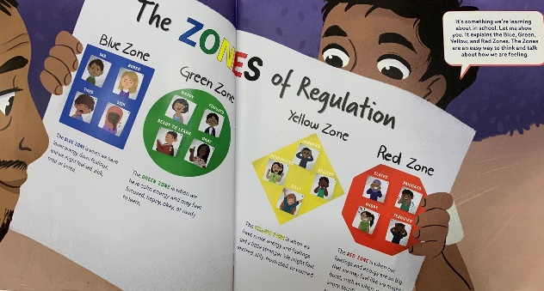

It is also possible to use NDIS funding to help reach the goal of emotional regulation!

